February 19, 2019

Kensington Management Group, Ltd. (Re: Evolution Insurance Company, Ltd.)
PO Box 10027
Grand Cayman KY1-1001
CAYMAN ISLANDS
For Attn of: Head of Insurance Supervision

RE: Nominated Director – Thomas M. Bonczek

To Whom It May Concern:

I have known Thomas M. Bonczek for 3 years. He has been a client of mine during that time and we interact regularly. During our relationship, Tom has consistently been a hard-working, conscientious and competent individual.

In my view, Tom is honest and fair, uses good judgment, and has an impeccable reputation for his integrity. I respect Tom as a person and am proud to recommend him as a representative on your Board.

Should you have any questions, or if I can be of further assistance, please do not hesitate to contact me.

If you have any questions, please do not hesitate to contact me.

Very truly yours,
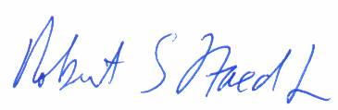
Robert E. Staed, Jr., J.D.
Principal

